Homework 1

**Due at the beginning of class on May 22 (Tuesday)**

Answer the following questions as clearly as possible. Bullet points are fine. (TOTAL 100 Points)

* **Conceptual Questions:**

**Q1. Basic Concepts of Trade (5 Points)**

1. Provide the reasons for the resurgence of trade that led to the second golden age.

**Q2. Ricardian Model (15 Points)**

1. Give four reasons for why countries trade goods with each other.
2. What are the assumptions of the Ricardian Model?
3. According to Ricardo’s theory of comparative advantage theory, briefly discuss how relative technological difference determines pattern of trade.

**Q3. Specific Factor Model (10 Points)**

1. How does the Specific Factor Model differ from the Ricardian Model?
2. Home is considering whether to engage in the international trade of apples and oranges. Suppose that the world price of apple is lower than Home’s no-trade price but its no-trade orange price is lower than the world price. Assume that land is specific to the production of apple and that labor is free to move across sectors. Do you think the landowners will support the move to free trade? Explain.

* **Numerical Questions: (40 Points)**

**Q4.**

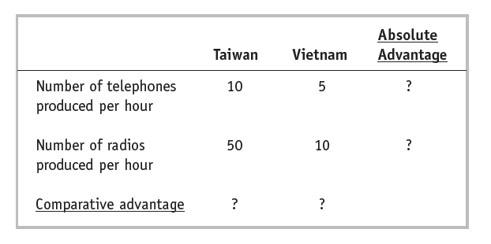

1. Which country has absolute advantage in the production of telephones? radios?
2. Which country has a comparative advantage in the production of telephones? radios?
3. Assume that the total labor supply in Taiwan is 4 and the total labor supply in Vietnam is 8. Draw the PPF for each country. Please label the maximum output levels.
4. Determine the pre-trade relative price of telephones in Taiwan and Vietnam.
5. If the two countries engage in international trade, what will Taiwan produce and how many? Show the production point of Taiwan on its PPF.
6. If the two countries engage in international trade, what will Vietnam produce and how many? Show the production point of Vietnam on its PPF.
7. What is the real wage in Taiwan in terms of radio? What is the real wage in Vietnam in terms of telephone?
8. Under free trade, what is the lower limit of the free-trade equilibrium price of telephone in terms of radio?

* **Empirical Questions:**

**Q5. Go to the website of FRED data. (30 Points)**

1. Go to this link: <https://fred.stlouisfed.org/series/BOPSTB>

Here you will find the Trade balance of the US for services. Print the graph, explain the trends, try to identify the period of trend shifts (showed by the gray color) and identify financial or economic events that happened during these periods which may have caused the change.

1. Go to this link: <https://fred.stlouisfed.org/series/BOPGTB>

Here you will find the Trade balance of the US for goods. Print the graph, explain the trends, try to identify the period of trend shifts (showed by the gray color) and identify financial or economic events that happened during these periods which may have caused the change.

*(Hint: For some recent information check the Wall Street Journal article “U.S. Foreign-Trade Deficit Narrowed in March” by  Ben Leubsdorf. The article is posted on Blackboard.)*

1. Compare the two graphs that you obtained in part (a) and (b).

(*Hints: 1. Keep the cursor on the graphs and check the sign and magnitude of the values; 2. Direction of overall trend*)

**\*\*\*\*\*\*\*\*\*\*\*\*\*\*\*\*\*\*\*\*\*\*\*\*\*\*\*\*\*\*\*\*\*\*\*\*\*\*\*\*\*\*\*\*\*\*\*\*\*\*\*\*\*\*\*\*\*\*\*\*\*\*\*\*\*\*\*\*\*\*\*\*\*\*\*\*\*\*\***

* **Bonus Problem: (10 Points)**

**Q6.** Explain the concept of value added in the light of the Atlantic article “Which Countries Make Money Off the iPad?” by Jordan Weissmann. (The article is posted on Blackboard).

**OR**

Following the Wall Street Journal article “China’s Faux Comparative Advantage” by Peter Navarro, discuss the limitations of Ricardo’s comparative advantage theory. (The article is posted on Blackboard)